**High Frequency Amplifier - Project Feasibility Report**

Pre Amplifier

INPUT

Power Amplifier

INPUT

## Pre-amplifier

In an amplifier, the ‘signal amplifier’ does the initial amplification and the removal of noises, while the ‘Power Amplifier’ provides the final amplification, which needs to connect a load. There were different kinds of preamplifier designs.

## 1.Pre-amplifier using BJT with

## common emitter configuration

This method is also simple and common. As the first step, we thought to work with this configuration and adjust the circuit according to the upcoming problems.

### **DC bias**

The power supply is 12v and we have made the DC biasing point (Q point), such that VCE, Q is closer to 6v.

### **Amplification mode**

First, we have selected a sinusoidal waveform of 0.1v (peak to peak) with an initial frequency of 1kHz. We have first, analyzed the circuit without a load.

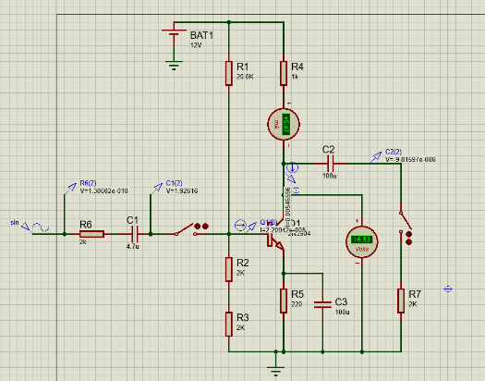

Figure 1